Charity Director, Glasgow School of Art Student’s Association (GSASA),
Job Description

Role Profile

Job Title | Charity Director
Reports to: | GSASA Board of Trustees (main contact – Student President)
Direct reports: | 3 x Engagement Coordinator, Admin Assistant, Finance Officer
Location: | GSASA Assembly Building, 20 Scott Street, Glasgow  (some WFH possible via discussion)
Working patterns: | Full time permanent position  1.0FTE with typical working hours 10am – 5.30pm, Monday to Friday. 37.5 hours/week including paid lunch breaks. This post may require some evening working.  Annual leave: 31 days + 11 holidays
Salary: | £45,320  21.5% ER and 5.0% EE
Other information: | This post is subject to a six-month probationary period and three-months’ notice of termination by either party, subject to usual employment law requirements.

Deadline for applications – 13th August at 5pm

Background

We are a registered Scottish Charity and independent Students’ Association which supports and promotes the interests of its student members while studying at the Glasgow School of Art. We are seeking to recruit a Charity Director to manage our dedicated team of student support staff and work with our Board of Trustees and Sabbatical Officers to further the objectives of the Students’ Association. We are committed to the organisation being student-led.

The Students’ Association is committed to widening access to education and the arts. We want to offer space and support to all students and members regardless of their resources and experience. The Association is committed to programming and working with organisers who reflect our student communities and their values, concerns and interests. We particularly offer opportunities to our student members that enable their personal and professional development during their time at GSA.

What does ‘student-led’ mean to us at GSASA?

To us, ‘student-led’ means actively listening to student voices, and enabling our student sabbatical leaders to guide and advocate for the resources and support students’ needs to make their time at GSA the most ambitious and creative experience that it can be. We will provide resources, passion and guidance, physical spaces and financial support – the structures and tools to enable students to thrive.

Purpose of Role

It is an exciting time to join GSASA as we are mid-way through key strategic and policy developments which the Charity Director will take on lead responsibility for. Our four priority areas are: (1) developing our student-led approach, (2) accessibility and inclusion, (3) evolving operational frameworks, (4) providing feedback and evaluation. The Charity Director will also take the lead in monitoring, developing, and implementing the charity’s policies such as complaints handling and safe(r) spaces.

We are developing the Charity structure in order to support the increased GSASA activity. The past academic year saw the substantial reopening of the GSASA Assembly building, post-covid, for daytime and evening events, activities, and services. Our casework, student-societies, and sabbatical projects have all increased in scope. Our new Finance Officer (to be hired concurrently) will enable the Charity Director to focus on strategic developments, staff management and support, and ensure the GSASA delivers the best for the students.

In summary, the Charity Director has the overall responsibility for the effective running of the Association, for the full benefit of students in accordance with the GSASA mission statement [https://www.thegsasa.com/page-1x2].

What is the Charity Director’s role in being ‘student-led’?

A key role, along with other Students’ Association staff, is in supporting and providing guidance, counsel and resources to empower the two elected Sabbatical Officers, which could include using frameworks, tools and policies established by the Board of Trustees. Sabbatical Officers will work to deliver the manifesto pledges on which they have been elected and provide leadership for the student body, and the Charity Director is responsible for supporting the Office to fulfill these but also making judgement about where these may require charitable governance input from the Board of Trustees.

At times, as the Charity Director, this may mean acting under your own initiative to support change, provided it is in line with the Sabbatical Officers’ pledges and the GSASA strategic vision, policies and procedures. This may also mean bringing options, challenges and recommendations to Sabbatical Officers regarding change they are advocating for, and to the Board of Trustees for discussions and decisions, where appropriate. You will be responsible for the day-to-day management, implementation and internal running of the GSASA, its staff team, and its buildings and spaces, while also cognisant of external relationships and the welfare and interests of the student body.

The GSASA’s status as a charity provides the education and support focus for the organisation and the role, which combined with our key value of being student led, form the cornerstones of the Team Leader post.

Key Responsibilities

Strategic Leadership
- To provide compassionate leadership through the management of staff, and through decision making that is confident, considerate, and informed by the Sabbatical Officers and student-led nature of the charity.
- To maintain, develop, and implement GSASA policies.
- Take leadership of the GSASA Strategic Plan, informed by stakeholder engagement.
- Advocate for the best interests of the students.
- Financial strategy and oversight – responsible for working with the new Finance Officer role, scrutinising financial documents, identifying key risks and areas for development, and writing the annual block grant funding request based upon the student-led priorities.

Governance
- Write and present papers to the GSASA Board of Trustees, with clear options and recommendations.
- Responsible for the OSCR annual reporting.
- Creation of a more robust feedback and evaluation process from staff, students and key stakeholders for Association activities and impact.
- To operate a risk management strategy within the Association to ensure all strategic decisions by the Board and Officers are taken when informed of potential risks and opportunities.

Management (People and Operational)
- To manage and support the GSASA staff body by setting clear work objectives, reviewing and assisting with progress and providing motivation and leadership.
- To support the Sabbatical Officers to achieve their manifesto aims.
- To be responsible for HR procedures and practice.
- To maintain regular communication with key stakeholders (including the GSASA Board of Trustees, students, GSA staff, and the Glasgow creative scene).
- To manage external contracts and contractors as part of general GSASA operations or as part of the role of supporting sabbatical officer manifesto activities.
- Writing and signing off risk assessments.
- To be comfortable working in a hands-on office environment, managing your own inbox and diary, and comfortably using MS programs.
- Making the workplace at the Association a creative, supportive, and inclusive environment.

Key relationships

- Internal: Sabbatical Officers, GSASA Board of Trustees, GSASA staff
- External: GSA staff, other student and arts organisations.
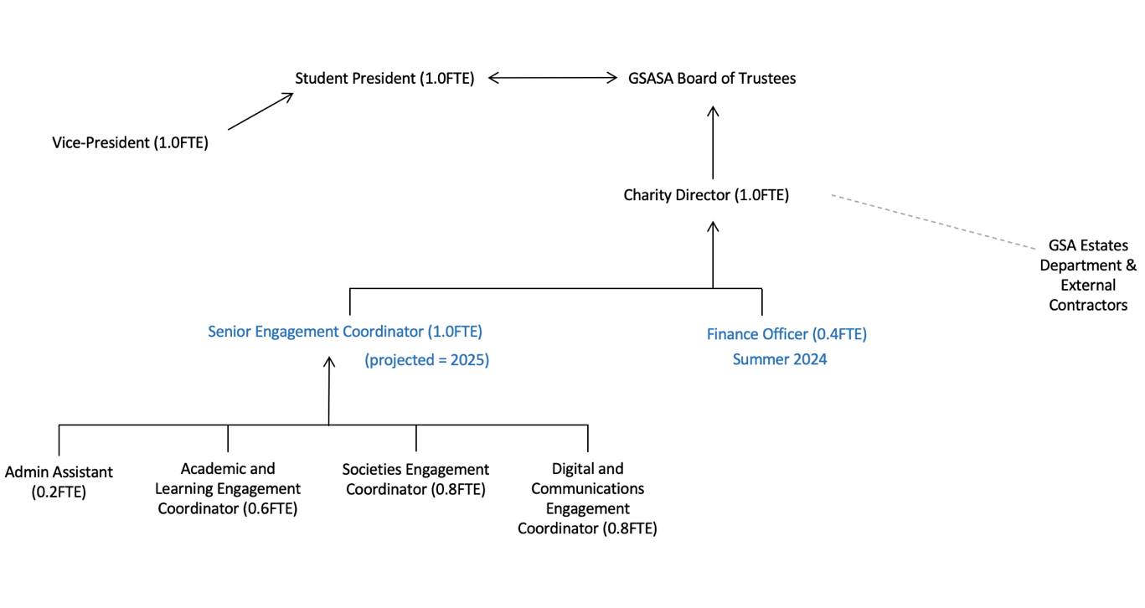

Person Specification

Qualifications | Essential | Desirable
Educated to degree and/or equivalent level of experience in a relevant field | X
Knowledge and Experience
Experience of managing staff (within a small, values-driven team) | X
Knowledge/experience of working in, or with, student unions/associations, universities/colleges, or public organisations | X
Knowledge/experience in policy writing, implementation, monitoring, and feedback | X
Knowledge/experience of strategic thinking, and/or strategic plan development | X
Knowledge/experience of financial strategy and oversight | X
Leadership experience | X
Knowledge of current HR legislation and practice | X
Experience of working with/in a board of trustees, or knowledge of charity governance/reporting/regulations |  | X
Experience of working with a charity |  | X
Experience in management of external contractors |  | X
Skills
Excellent and demonstrable facilitation skills | X
Excellent and demonstrable project management skills | X
Excellent time management skills and ability to work with minimal supervision | X
Excellent written and oral communication skills | X
Proficiency in IT systems, social media, and use of MS and zoom | X
Successful proposal writing and/or finance bid skills | X
Confident skills in operating a risk management strategy in order to provide leadership and direction to the charity |  | X
Confident to reach out to and liaise with a wide range of stakeholders |  | X
Active listening skills |  | X
Ability and desire to learn new skills | X
Attributes
Confident in informed decision making and leadership | X
Highly proactive and able to use own initiative to solve complex problems effectively and imaginatively | X
Demonstrable commitment to actively engaging in environmental and social justice, accessibility, anti-racism, and/or, queer liberation, and ability to implement this knowledge into your working practices and lead by example | X
A facilitator/enabler/coach – someone who draws out the best in other people | X
Commitment to advocating for the needs of students and student representatives and working in a student-led environment | X
Enthusiasm for the arts and creative practices | X

Key dates

Application deadline: | 13th August at 5pm
Interview date: | 27th August
Start date: | 30th September (or as soon as possible after)
Application Process
Complete the application form, save it with your name in the title, and submit it via email to gsasa@gsa.ac.uk by 13th August at 5pm.
If you require the application form in another format, email gsasa@gsa.ac.uk
On the application form we ask you for two references. Any job offer will be conditional on satisfactory references from both named individuals/organisations on your application. We won’t contact your named reference providers before interview. Ideally, we’d like references from previous employers, but we are aware that is not always possible. They should, however, be able to comment on your suitability for this role and should not be a member of your family.
If you are successful and are offered the post, we would like you to start as soon as possible from the 30th September, so the offer will be subject to a satisfactory start date.
We welcome applications from everyone irrespective of sexual orientation, gender identity, sex, ethnicity, faith and religion, disability and age, and particularly welcome and encourage applications from trans people, Black People and People of Colour, neurodivergent people and disabled people. What we ask, is that you are committed to the ethos and values of the GSASA (respectfulness, supporting, rewarding, progressive and student-led) and have a genuine interest in the empowerment of students.
You must be UK based and eligible to work in the UK.

Interviews:
The interview process will take place in 2 parts. Firstly, a panel interview made up of key stakeholders and student representatives. Interviews will be one hour long and will take place in person on the 27th August 2024. We will e-mail you approximately a week before that with an interview time. If your application hasn’t been successful, we will e- mail you to let you know.
Secondly, a task-based activity with GSASA staff. There will be pre-interview prep for this task that you will be asked to complete. This is unlikely to take more than 30 minutes of your time and we will send it to you at least 3 days in advance of your interview.

Last updated: July 2024

